* 1. CREATE, INSERT, UPDATE, and DELETE

1.Create a new table in your IT143 database called “ProductsAnalysis” using all of the same fields from the Product table in AdventureWorkd19.

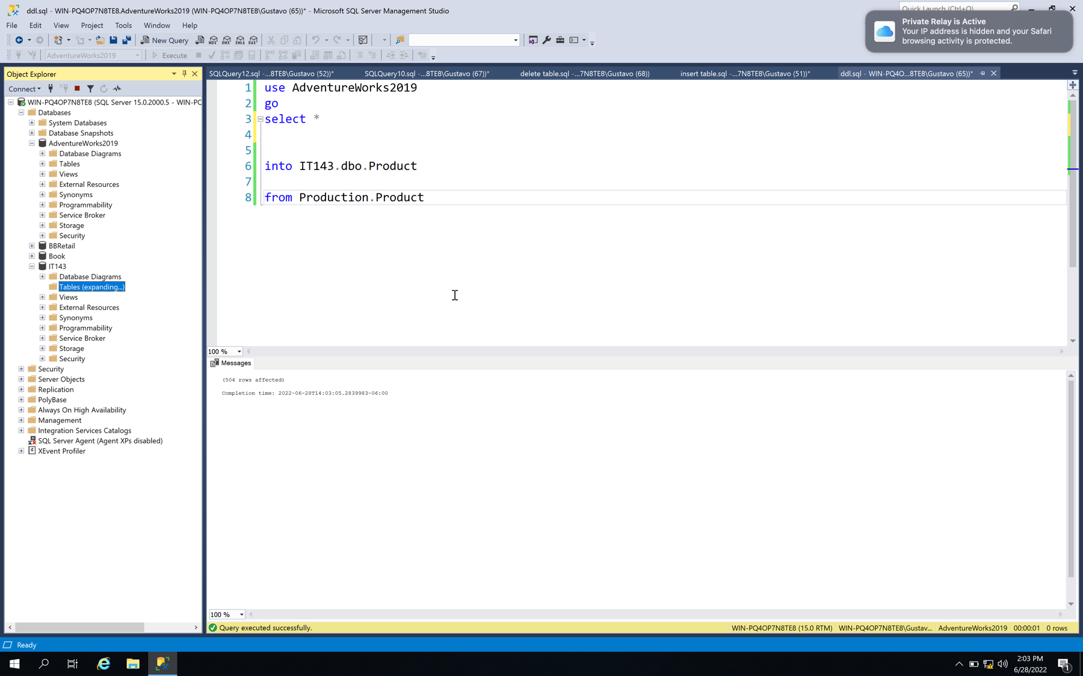

2.Insert all records from the Production.Products table into that newly created table.

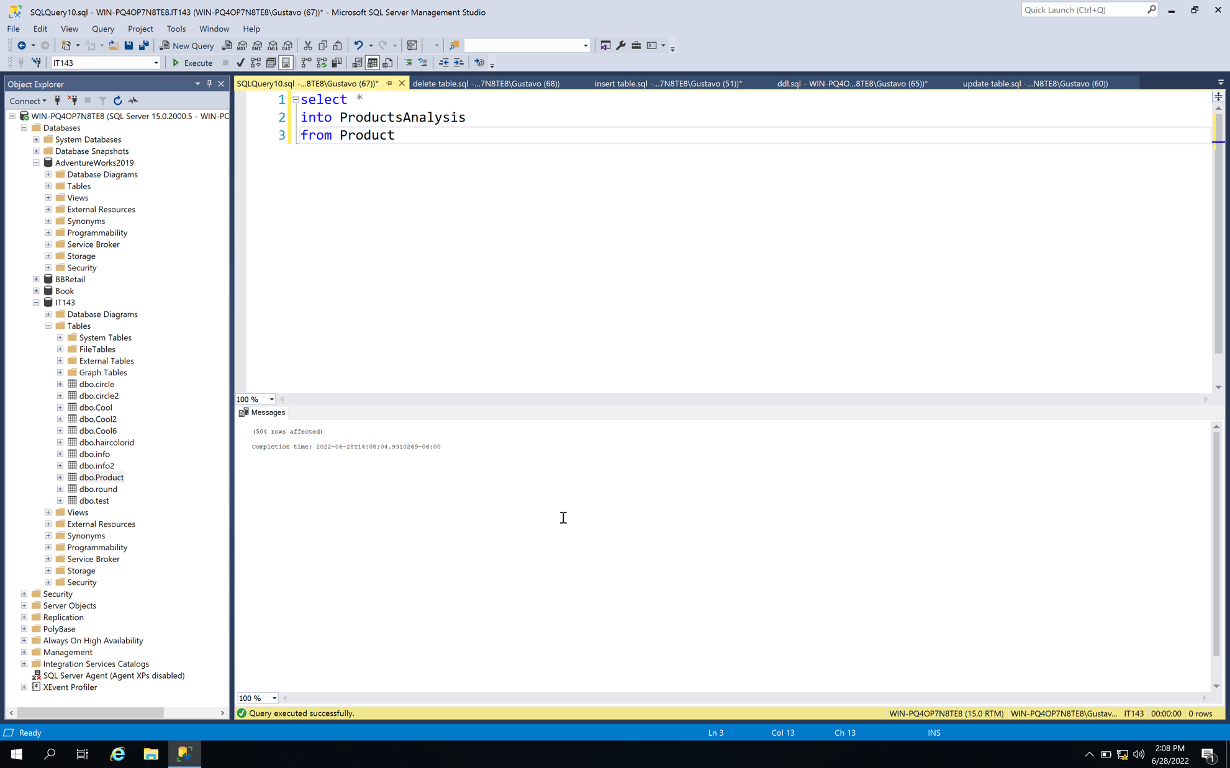

3.In the new table, update product color where the name says black to say dark, otherwise the color should stay the same.

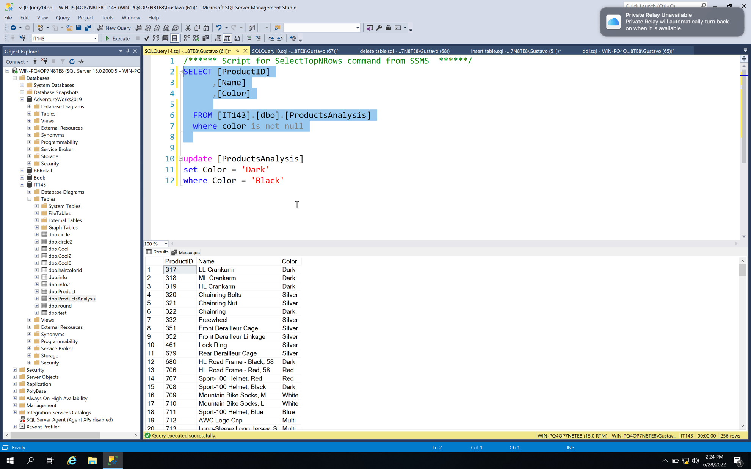

4.In the new table, delete all lines where color as missing.

